**Drapery plots**

Meta-analysis through forest plots provides a comprehensive way of understanding meta-analysis results. It can be argued, however, that forest plots can only display confidence intervals by assuming a fixed significant threshold (p<0.05). It causes a replication crisis when hypothesis tests are conducted using p values. Based on p-value functions, drapery plots were proposed to resolve this problem [65].

Using a drapery plot, an average effect and a confidence curve can be identified [65], [66]. Figure 4(a-d) presents the drapey plots of adopted studies. The x-axis shows the effect size metric, and the y-axis shows the assumed p-value. There is a red and blue curve showing the overall random and fixed effects model respectively that presents the p values for various effect sizes. Compared to the confidence interval of pooled effects, the shaded area represents the prediction range. The prediction range is noticeably wider than the confidence interval for the pooled effect. It is possible to identify the confidence intervals (predictions) for common Alpha levels (0.1, 0.05, 0.01). It indicates that the overall pooled effect does not fully capture the variability or uncertainty across different effect sizes.

Gray curves correspond to primary studies, with study weights from the random effects model represented on a grayscale (studies with higher precision are shown in dark gray, and studies with low precision in light gray). Each point estimate can be read off at the peak of the respective curve.

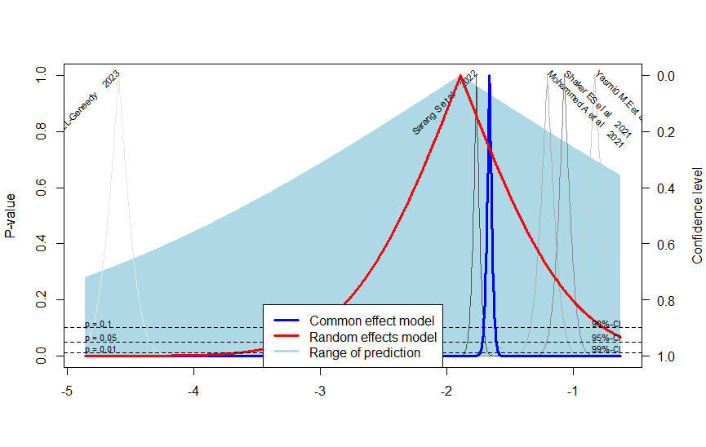Figure 4.a. Drapery plot representation of 2-stage AD classification studies

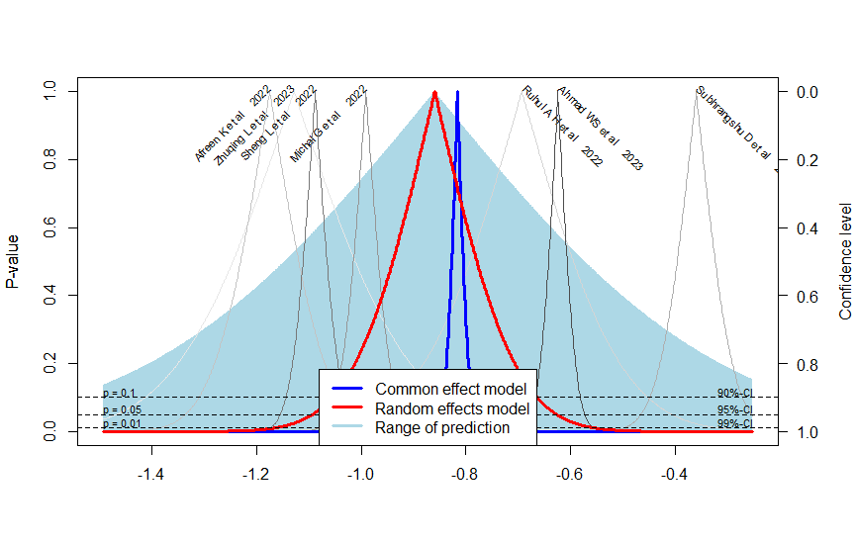

Figure 4.b. Drapery plot representation of 3-stage AD classification studies



Figure 4.c. Drapery plot representation of 4-stage AD classification studies

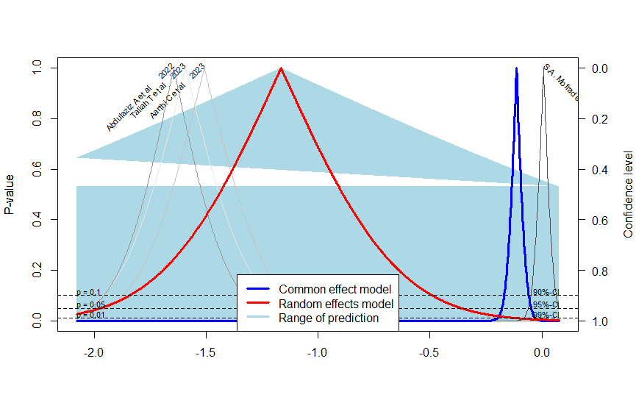

Figure 4.d. Drapery plot representation of 6-stage AD classification studies

proportion 95%-CI %W(common) %W(random)

Abdulaziz A et al 2022 0.1618 [0.1140; 0.2196] 3.1 24.9

S.A. Mofrad et al. 2021 0.5016 [0.4845; 0.5188] 92.5 26.3

Aarthi C et al 2023 0.1812 [0.1208; 0.2557] 2.3 24.4

Taliah T et al 2023 0.1690 [0.1114; 0.2410] 2.2 24.4

Number of studies: k = 4

Number of observations: o = 3819

Number of events: e = 1755

proportion 95%-CI

Common effect model 0.4716 [0.4553; 0.4879]

Random effects model 0.2377 [0.1222; 0.4112]

Quantifying heterogeneity:

tau^2 = 0.6432 [0.1915; 8.8041]; tau = 0.8020 [0.4377; 2.9672]

I^2 = 98.1% [96.9%; 98.9%]; H = 7.31 [5.70; 9.38]

Test of heterogeneity:

Q d.f. p-value

160.39 3 < 0.0001